PROCEDURES : IS ALSO A PROG THAT WILL BE STORED IN DB

IN PROGRAMS / MEANS, COMPILES THE PROGRAM AND EXECUTES.

BUT IN PROCEDURE / MEANS JUST COMPILES THE PROCEDURE AND DOES NOT DISPLAY ANY OUTPUT.

HERE WE GETTING SAME OUTPUT BECAUSE INPUT IS SAME, SO WE GO FOR ARGUMENTS IN PROCEDURE CALLED DYNAMIC.

& DOES NOT WORK HERE

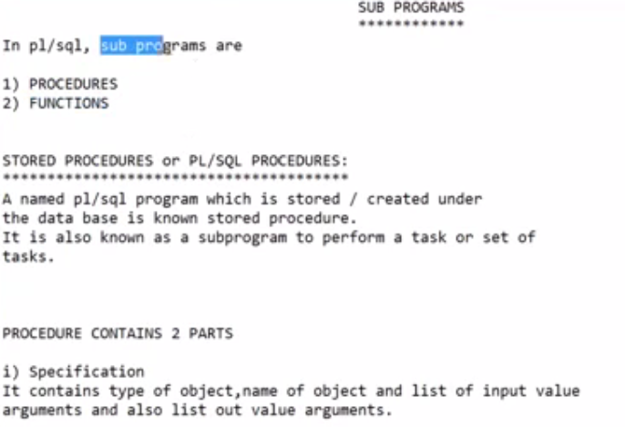

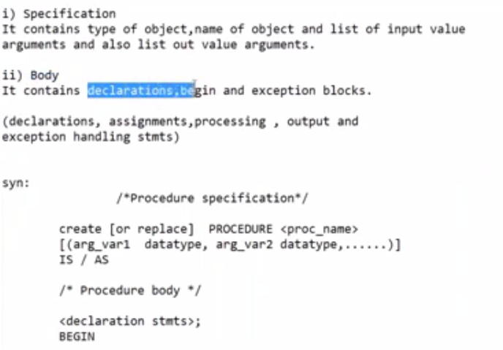

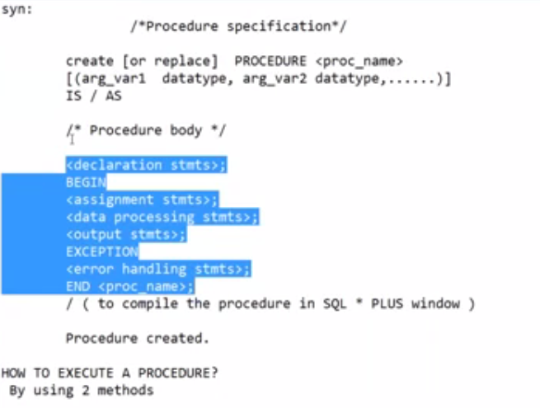

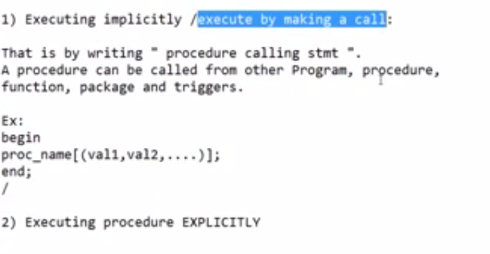

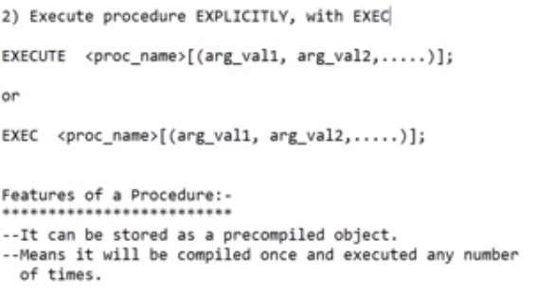

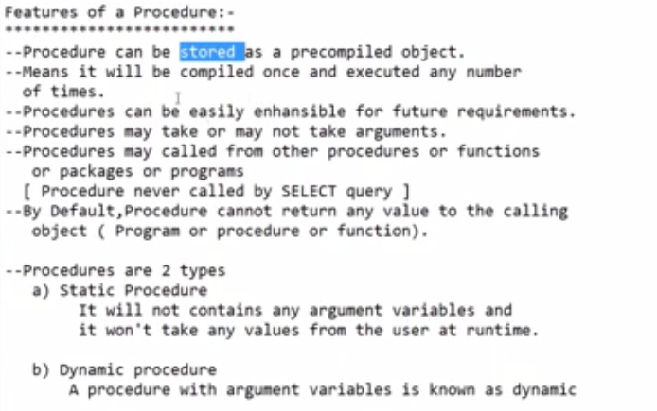

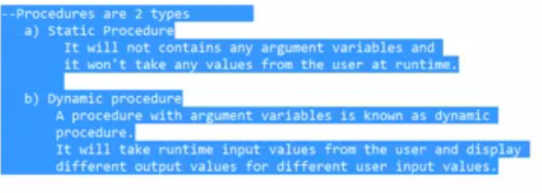

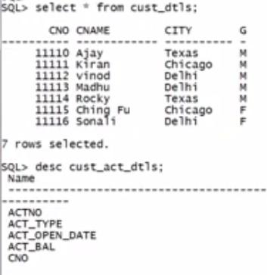

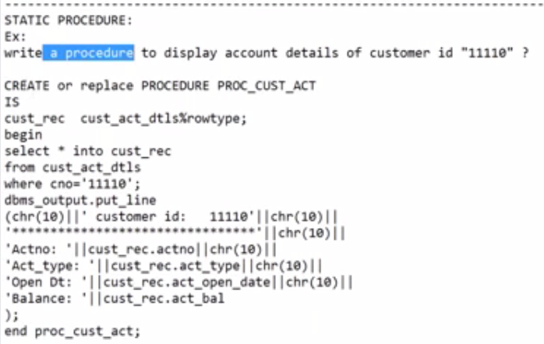

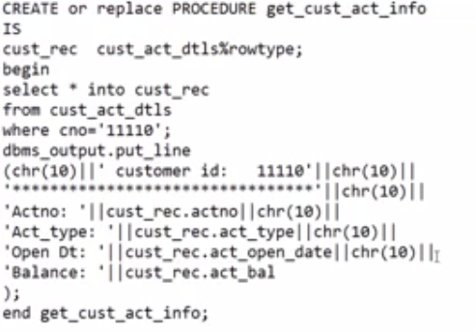

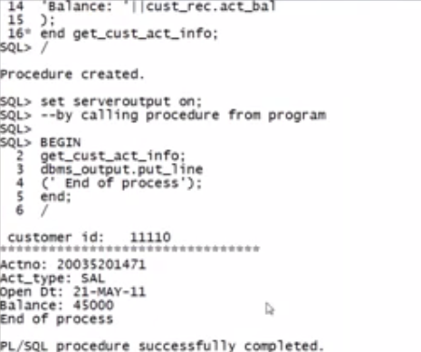

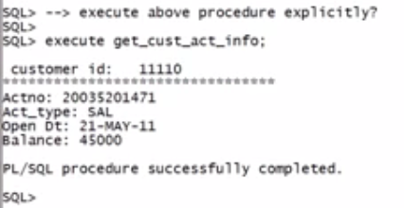

HERE WE GETTING SAME OUTPUT BECAUSE INPUT IS SAME, SO WE GO FOR ARGUMENTS IN PROCEDURE CALLED DYNAMIC.

& DOES NOT WORK HERE

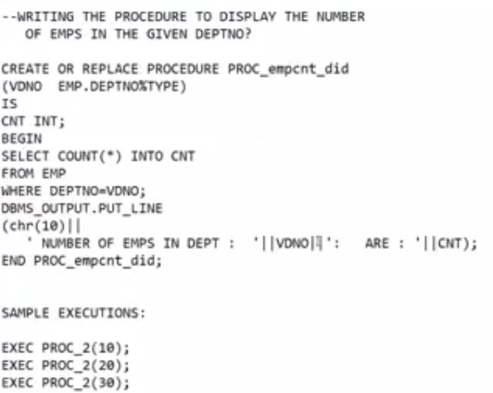

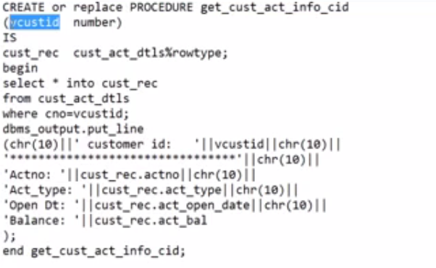

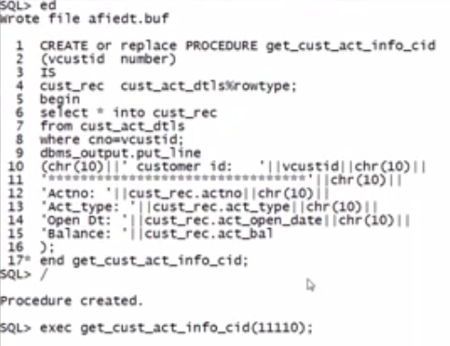

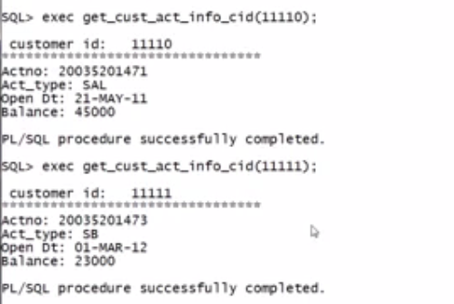

THERE ARE THOUSANDS OF TABLES, ITS NOT POSSIBLE TO REMEMBER ARGUMENTS FOR ALL PROC.

SO WE CAN DO AS FOLLOWING.

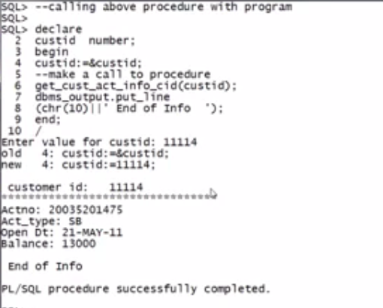

ACTUAL ARGUMENT IS VCUSTID BUT WE CAN DECLARE ANY VARIABLE IN PROG. AND THIS ARGUMENT CAN BE MENTIONED IN CALLING PROC. ARGUMENT AS INPUT.

SQL> ED

Wrote file afiedt.buf

1 CREATE PROCEDURE GET_TOTSALAR_AVGSALAR(DEPTNAME VARCHAR2)

2 AS

3 VTS NUMBER(10);

4 VAS NUMBER(10);

5 BEGIN

6 SELECT SUM(SAL), AVG(SAL) INTO VTS, VAS FROM EMP WHERE DEPTNO=(SELECT DEPTNO FROM DEPT WHERE DNAME=DEPTNAME);

7 DBMS_OUTPUT.PUT_LINE('TOTAL SALARY IS : '||VTS);

8 DBMS_OUTPUT.PUT_LINE('AVERAGE SALARY IS : '||VAS);

9* END GET_TOTSALAR_AVGSALAR;

SQL> /

Procedure created.

SQL> BEGIN

2 GET_TOTSALAR_AVGSALAR('SALES');

3 END;

4 /

PL/SQL procedure successfully completed.

SQL> SET SERVEROUTPUT ON;

SQL> /

TOTAL SALARY IS : 9400

AVERAGE SALARY IS : 1567

PL/SQL procedure successfully completed.

SQL> /

DEPTNO DNAME LOC

---------- -------------- -------------

10 ACCOUNTING NEW YORK

20 RESEARCH DALLAS

30 SALES CHICAGO

40 OPERATIONS BOSTON

SQL> BEGIN

2 GET_TOTSALAR_AVGSALAR('SALES');

3 END;

4 /

TOTAL SALARY IS : 9400

AVERAGE SALARY IS : 1567

PL/SQL procedure successfully completed.

SQL> ED

Wrote file afiedt.buf

1 BEGIN

2 GET_TOTSALAR_AVGSALAR('ACCOUNTING');

3* END;

SQL> /

TOTAL SALARY IS : 8750

AVERAGE SALARY IS : 2917

PL/SQL procedure successfully completed.

SQL> ED

Wrote file afiedt.buf

1 BEGIN

2 GET_TOTSALAR_AVGSALAR('RESEARCH');

3* END;

SQL> /

TOTAL SALARY IS : 10875

AVERAGE SALARY IS : 2175

PL/SQL procedure successfully completed.

SQL> ED

Wrote file afiedt.buf

1 BEGIN

2 GET_TOTSALAR_AVGSALAR('ACCOUNTING');

3* END;

SQL> /

TOTAL SALARY IS : 8750

AVERAGE SALARY IS : 2917

PL/SQL procedure successfully completed.

SQL>

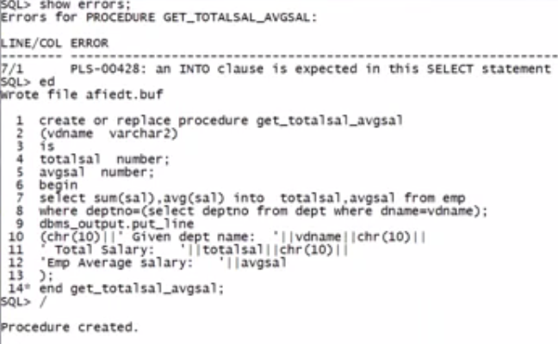

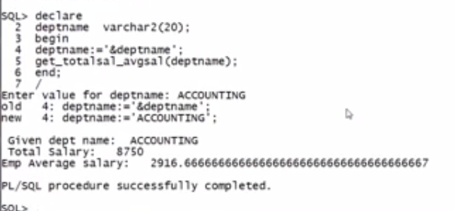

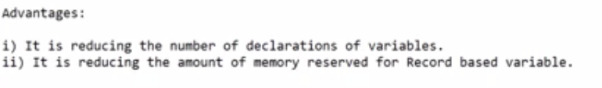

SUB PROGRAMS

************

In pl/sql, sub programs are

1) PROCEDURES

2) FUNCTIONS

STORED PROCEDURES or PL/SQL PROCEDURES:

***************************************

A named pl/sql program which is stored / created under

the data base is known stored procedure.

It is also known as a subprogram to perform a task or set of

tasks.

PROCEDURE CONTAINS 2 PARTS

i) Specification

It contains type of object,name of object and list of input value

arguments and also list out value arguments.

ii) Body

It contains declarations,begin and exception blocks.

(declarations, assignments,processing , output and

exception handling stmts)

syn:

/*Procedure specification*/

create [or replace] PROCEDURE <proc_name>

[(arg_var1 datatype, arg_var2 datatype,......)]

IS / AS

/* Procedure body */

<declaration stmts>;

BEGIN

<assignment stmts>;

<data processing stmts>;

<output stmts>;

EXCEPTION

<error handling stmts>;

END <proc_name>;

/ ( to compile the procedure in SQL * PLUS window )

Procedure created.

HOW TO EXECUTE A PROCEDURE?

By using 2 methods

1) Execute procedure by making a call:

That is by writing " procedure calling stmt ".

A procedure can be called from other Program, procedure,

function, package and triggers.

Ex:

begin

proc_name[(val1,val2,....)];

end;

/

2) Execute procedure EXPLICITLY, with EXECUTE command.

EXECUTE <proc_name>[(arg_val1, arg_val2,.....)];

or

EXEC <proc_name>[(arg_val1, arg_val2,.....)];

Features of a Procedure:-

*************************

--Procedure can be stored as a precompiled object.

--Means it will be compiled once and executed any number

of times.

--Procedures can be easily enhansible for future requirements.

--Procedures may take or may not take arguments.

--Procedures may called from other procedures or functions

or packages or programs

[ Procedure never called by SELECT query ]

--By Default,Procedure cannot return any value to the calling

object ( Program or procedure or function).

-----------------------------------------------------------------------------------------

Ex:

write a procedure to display account details of customer id "11110" ?

CREATE or replace PROCEDURE PROC_CUST_ACT

IS

cust_rec cust_act_dtls%rowtype;

begin

select * into cust_rec

from cust_act_dtls

where cno='11110';

dbms_output.put_line

(chr(10)||' customer id: 11110'||chr(10)||

'********************************'||chr(10)||

'Actno: '||cust_rec.actno||chr(10)||

'Act_type: '||cust_rec.act_type||chr(10)||

'Open Dt: '||cust_rec.act_open_date||chr(10)||

'Balance: '||cust_rec.act_bal

);

end proc_cust_act;

Ex:

Write a procedure to find number of customers from the city

"Delhi"?

create or replace procedure proc_cust_cnt_delhi

is

vcnt int;

begin

select count(*) into vcnt

from cust_dtls where city='Delhi';

dbms_output.put_line

(chr(10)||

'City: Delhi'||chr(10)||

'Customer Count: '||vcnt

);

end;

Ex:

write a procedure which is finding number of emps working

under dept 30?

create procedure proc_empcount_30

is

e_count int;

begin

select count(*) into e_count

from emp

where deptno=30;

dbms_output.put_line

(' Number of emps under deptno 30 are: '||e_count);

end proc_empcount_30;

Ex: execute proc_ecount_30; /* Executing procedure explicitly */

How do i execute a procedure implicitly?

By making a call to the procedure we can implicitly execute the procedure.

--Calling a procedure from any program

BEGIN

proc_ecount_30; --Procedure calling stmt

dbms_output.put_line(' calling procedure is finished');

dbms_output.put_line(' Program Execution is finished');

end;

--WRITING THE PROCEDURE TO DISPLAY THE NUMBER

OF EMPS IN THE GIVEN DEPTNO?

CREATE OR REPLACE PROCEDURE PROC_empcnt_did

(VDNO EMP.DEPTNO%TYPE)

IS

CNT INT;

BEGIN

SELECT COUNT(*) INTO CNT

FROM EMP

WHERE DEPTNO=VDNO;

DBMS_OUTPUT.PUT_LINE

(chr(10)||

' NUMBER OF EMPS IN DEPT : '||VDNO||': ARE : '||CNT);

END PROC_empcnt_did;

SAMPLE EXECUTIONS:

EXEC PROC_2(10);

EXEC PROC_2(20);

EXEC PROC_2(30);

anonymous block completed

NUMBER OF EMPS IN DEPT 10 ARE 2

anonymous block completed

NUMBER OF EMPS IN DEPT 20 ARE 5

anonymous block completed

NUMBER OF EMPS IN DEPT 30 ARE 6

ex:

declare

vdno int;

begin

vdno:=&vdno;

proc_ecount_did(vdno); --Procedure calling statement

dbms_output.put_line(' Exec Finished');

end;

WRITING PROCEDURE CALLING STATEMENTS IN A PROGRAM:-

For the following program we need to create

2 procedures called p_add and p_multi.

declare

x int;

y int;

begin

x:=&x;

y:=&y;

dbms_output.put_line(' adding '||x ||' and '||y);

Dbms_output.put_line(' Making a call to P_ADD procedure');

p_add(x,y);

dbms_output.put_line(' Multiplication of '||x||' and '||y);

dbms_output.put_line(' make a call to P_MULTI procedure');

p_multi(x,y);

dbms_output.put_line(' 2 tasks successfully completed');

end;

Ex:

wap to display customer name,city,account name,actno and bal

from given customer id?

create or replace procedure proc_cust_info

(vcid cust_dtls.cno%type)

as

type cust_type IS RECORD

(

cname cust_dtls.cname%type,

city cust_dtls.city%type,

act_name act_types.act_name%type,

actno cust_act_dtls.actno%type,

actbal cust_act_dtls.act_bal%type

);

Vcustrec cust_type;

begin

select cd.cname,cd.city,at.act_name,cad.actno,cad.act_bal

into

vcustrec

from cust_dtls cd, cust_act_dtls cad, act_types at

where cd.cno=vcid

and

(

cd.cno=cad.cno

and

cad.act_type=at.act_type

);

dbms_output.put_line

(chr(10)||' Given customer Id: '||vcid||chr(10)||

'-----------------------------------------------'||chr(10)||

'Cust name: '||vcustrec.cname||chr(10)||

'City: '||vcustrec.city||chr(10)||

'Account Name: '||vcustrec.act_name||chr(10)||

'Account Number: '||vcustrec.actno||chr(10)||

'Balance: '||vcustrec.actbal

);

end proc_cust_info;

/

Ex:

write a procedure to display the customer details and

his account details for the custid "cust-5"?

create or replace procedure proc_CUST_ACT_DTLS

is

v_cname cust_dtls.cname%type;

v_gender cust_dtls.gender%type;

v_city cust_dtls.city%type;

v_actno cust_act_dtls.actno%type;

v_act_type cust_act_dtls.act_type%type;

v_act_bal cust_act_dtls.act_bal%type;

begin

select c.cname,c.gender,c.city,ca.actno,ca.act_type,ca.act_bal INTO

V_CNAME,v_gender,v_city,v_actno,v_act_type,v_act_bal

from cust_dtls c , cust_act_dtls ca

where c.cno='cust-5'

and

c.cno=ca.cust_code;

dbms_output.put_line(' Details of customer 5');

dbms_output.put_line(v_cname||' '||v_gender||' '||v_city||' '||v_actno||' '||v_act_type||' '||v_act_bal);

end proc_CUST_ACT_DTLS;

Ex:

write a procedure to display the customer details and his account

details for the GIVEN custid ?

create or replace procedure proc_3

(VCID cust_dtls.cno%type)

is

v_cname cust_dtls.cname%type;

v_gender cust_dtls.gender%type;

v_city cust_dtls.city%type;

v_actno cust_act_dtls.actno%type;

v_act_type cust_act_dtls.act_type%type;

v_act_bal cust_act_dtls.act_bal%type;

begin

select c.cname,c.gender,c.city,ca.actno,ca.act_type,ca.act_bal INTO

V_CNAME,v_gender,v_city,v_actno,v_act_type,v_act_bal

from cust_dtls c , cust_act_dtls ca

where c.cno=VCID

and

c.cno=ca.cust_code;

dbms_output.put_line(' Details of customer '||VCID);

dbms_output.put_line(v_cname||' '||v_gender||' '||v_city||' '||v_actno||' '||v_act_type||' '||v_act_bal);

end proc_3;

Ex:

Ex:

write a procedure to display the customer details and his account

details for the GIVEN custid ?

create or replace procedure proc_3

(VCID cust_dtls.cno%type)

is

type cust_type is record

(

custname cust_dtls.cname%type,

custcity cust_dtls.city%type,

gender cust_dtls.gender%type,

actno cust_act_dtls.actno%type,

act_type cust_act_dtls.act_type%type,

act_bal cust_act_dtls.act_bal%type

);

vactdtls cust_type;

begin

select c.cname,c.city,c.gender,

cad.actno,cad.act_type,cad.act_bal

INTO

vactdtls

from cust_dtls c , cust_act_dtls cad

where c.cno=VCID

and

c.cno=cad.cno;

dbms_output.put_line

(' Details of customer: '||VCID||CHR(10)||

'************************************');

dbms_output.put_line

(

chr(10)||

'Name: '||vactdtls.custname||chr(10)||

'City: '||vactdtls.custcity||chr(10)||

'gender: '||vactdtls.gender||chr(10)||

'A/c No: '||vactdtls.actno||chr(10)||

'A/c Type: '||vactdtls.act_type||chr(10)||

'Balance: '||vactdtls.act_bal

);

end proc_3;

Ex: write a procedure to display the employee details and dept details for the empno 7902?

create or replace procedure proc_4

is

v_ename emp.ename%type;

v_job emp.job%type;

v_sal emp.sal%type;

v_hiredate emp.hiredate%type;

v_dno emp.deptno%type;

v_dname dept.dname%type;

v_loc dept.loc%type;

begin

select e.ename,e.sal,e.job,e.hiredate,e.deptno,d.dname,d.loc INTO

v_ename,v_sal,v_job,v_hiredate,v_dno,v_dname,v_loc

from emp e , dept d

where e.empno=7902 and e.deptno=d.deptno;

dbms_output.put_line('Details of empno= 7902');

dbms_output.put_line(v_ename||' '||v_job||' '||v_sal||' '||v_hiredate||' '||v_dno||' '||v_dname||' '||v_loc);

end proc_4;

DYNAMIC PROCEDURES:

EX: write a procedure to display the details of employee for the given employee id?

create or replace procedure proc_5 ( vempid emp.empno%type)

is

emp_rec emp%rowtype;

begin

select * into emp_rec from emp where empno=vempid;

dbms_output.put_line(' employee details of '||vempid);

dbms_output.put_line(' ***********************************************************************');

dbms_output.put_line(emp_rec.ename||','||emp_rec.sal||','||emp_rec.job||','||emp_rec.hiredate);

end proc_5;

sample output:

employee details of 7902

FORD,3000,ANALYST,03-DEC-81

anonymous block completed

employee details of 7788

SCOTT,3000,ANALYST,19-APR-87

anonymous block completed

employee details of 7654

MARTIN,1250,SALESMAN,28-SEP-81

Ex: write a procedure to display the customer mobile number and name of the given custid if he is male and from the city delhi?

desc cust_dtls

Name Null Type

---------- ---- ------------

CUSTID CHAR(4)

CUSTNAME VARCHAR2(20)

CUSTCITY VARCHAR2(10)

CUSTGENDER CHAR(1)

CUSTMOBILE NUMBER(10)

create or replace procedure proc_5(vcid cust_dtls.cno%type) is

--vmobile cust_dtls.mobile%type;

vcustname cust_dtls.cname%type;

begin

select cname into vcustname

from cust_dtls

where cno=vcid and gender='M' and city='Delhi';

dbms_output.put_line(' give customer id='||vcid);

dbms_output.put_line(' he is male and he is from delhi');

--dbms_output.put_line('mobile number is -'||vmobile);

dbms_output.put_line(' His name is '||vcustname);

end proc_5;

Ex: write a procedure to display number of emps working under given department name?

Ex: write a procedure to display the number of customers from the given city with given gender?

Ex: write a procedure to display the number of accounts of given account type?

1 create or replace procedure proc_insert_accounts

2 (argactno cust_act_dtls.actno%type,

3 argacttype cust_act_dtls.act_type%type,

4 argopendt cust_act_dtls.act_open_date%type,

5 argactbal cust_act_dtls.act_bal%type,

6 argcno cust_act_dtls.cno%type

7 )

8 is

9 reccnt int;

10 begin

11 select count(*) into reccnt

12 from cust_act_dtls;

13 dbms_output.put_line

14 (chr(10)||' old Record count : '||reccnt);

15 insert into cust_act_dtls values

16 (argactno,argacttype,argopendt,argactbal,argcno);

17 dbms_output.put_line

18 (chr(10)||' record inserted successfully');

19 select count(*) into reccnt

20 from cust_act_dtls;

21 dbms_output.put_line

22 (chr(10)||' New Record count : '||reccnt);

23* end proc_insert_accounts;

SQL> /

Procedure created.

SQL> declare

2 vactno cust_act_dtls.actno%type;

3 vacttype cust_act_dtls.act_type%type;

4 vactopendt date;

5 vactbal number;

6 vcno cust_act_dtls.cno%type;

7 begin

8 vactno:='&vactno';

9 vacttype:='&vacttype';

10 vactopendt:=sysdate;

11 vactbal:='&vactbal';

12 vcno:='&vcno';

13 proc_insert_accounts

14 (vactno,vacttype,vactopendt,vactbal,vcno);

15 end;

16 /

Enter value for vactno: 20035201489

old 8: vactno:='&vactno';

new 8: vactno:='20035201489';

Enter value for vacttype: CA

old 9: vacttype:='&vacttype';

new 9: vacttype:='CA';

Enter value for vactbal: 35000

old 11: vactbal:='&vactbal';

new 11: vactbal:='35000';

Enter value for vcno: cust-1

old 12: vcno:='&vcno';

new 12: vcno:='cust-1';

old Record count : 7

record inserted successfully

New Record count : 8

PL/SQL procedure successfully completed.

SQL>

Ex:

write a procedure to display number of customers from given

account type with min bal 20000?

SQL> create or replace procedure proc_cust_cnt

2 (vact_type cust_act_dtls.act_type%type)

3 is

4 vcnt int;

5 begin

6 select count(*) into vcnt

7 from cust_act_dtls

8 where act_type=vact_type

9 and

10 act_bal>=20000;

11 dbms_output.put_line

12 (chr(10)||

13 'Given account type: '||vact_type||chr(10)||

14 'Number of customers: '||vcnt

15 );

16 end;

17 /

Ex: Write a procedure to display the name,sal,job,

hiredate,deptno for the given employee id?

create or replace procedure proc_emp( veno emp.empno%type)

is

type erec is record(

name emp.ename%type,

esal emp.sal%type,

desg emp.job%type,

jdate emp.hiredate%type,

dno emp.deptno%type

);

rec erec;

begin

select ename,sal,job,hiredate,deptno into rec

from emp where empno=veno;

dbms_output.put_line(' Ename='||rec.name);

dbms_output.put_line(' EmpSal='||rec.esal);

dbms_output.put_line(' Emp Job Title='||rec.desg);

dbms_output.put_line(' Emp join date='||rec.jdate);

dbms_output.put_line(' Emp Dept No='||rec.dno);

end proc_emp;

Advantages:

i) It is reducing the number of declarations of variables.

ii) It is reducing the amount of memory reserved for Record based variable.

Ex:

Write a procedure to display the name,cost and warrenty of the

product for the given product id?

Ex:

Write a procedure to display pname,cost,mfg,exp,companyName,Dealer

address,phonenumber for the given product id?

EX:

write procedure to display customer name,city,gender,account

name, balance from given account number?

create or replace procedure proc_cust

(vactno IN cust_act_dtls.actno%type)

is

TYPE custtype IS RECORD

(

cname cust_dtls.cname%type,

city cust_dtls.city%type,

gender cust_dtls.gender%type,

actname act_types.act_name%type,

actbal cust_act_dtls.act_bal%type

);

vrec custtype;

begin

select a.cname,a.city,a.gender,b.act_name,

c.act_bal

into vrec

from cust_dtls a inner join cust_act_dtls c

on

c.actno=vactno

and

(a.cno=c.cno

inner join act_types b

on c.act_type=b.act_type);

dbms_output.put_line

(chr(10)||

'Account number: '||vactno||chr(10)||

'Customer name: '||vrec.cname||chr(10)||

'City: '||vrec.city||chr(10)||

'Gender: '||vrec.gender||chr(10)||

'Account Name: '||vrec.actname||chr(10)||

'Account Bal: '||vrec.actbal

);

end;

-----------------------------------------------------------------------------------------